

SUPPORT
Advantage Computer Solutions offers several support plan options to make your technology more reliable, efficient, productive, and profitable. When we maintain your computers, you can get back to doing what you do best.

GET WATCHDOG: WatchDog is our signature full network monitoring service. We track the performance and health of your server, all of your workstations, and other vital components of your network.
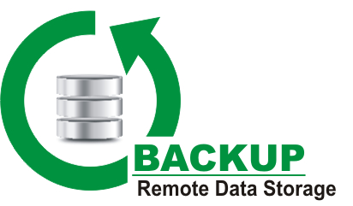
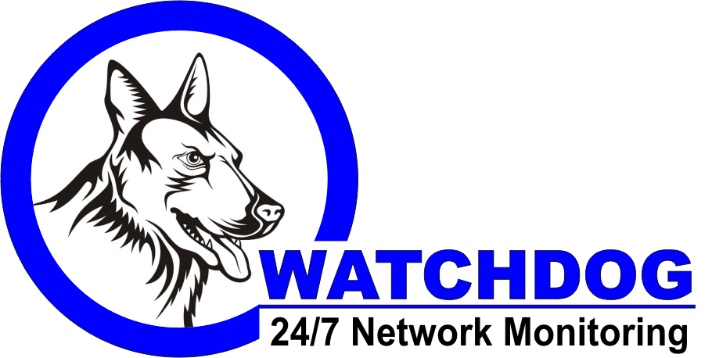
GET BACKUP: Remote Data Storage is a safe, secure, and simple way to backup all of your data automatically each day. Pricing is based upon the total amount of data.

GET VERIFIED: Now you can have the PEACE of MIND knowing of that your onsite backup solution is being checked every day by IT Professionals.

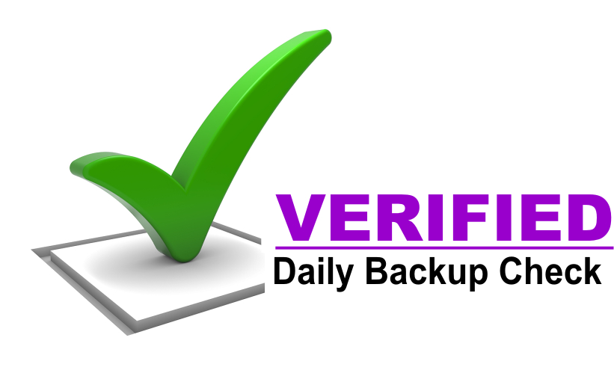
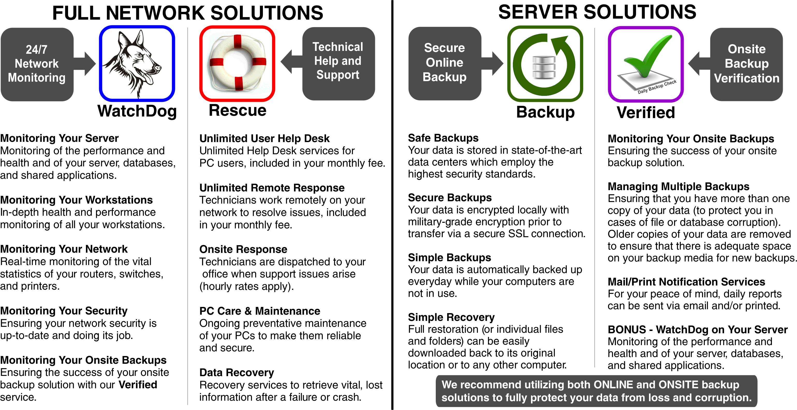
GET RESCUE: With Rescue, you quickly get the help and support you need with our unlimited user help desk and remote response service. We log in and resolve the problem.

